YUMC Yum China Holdings
  - Ticker – YUMC
  - Market Cap – $13.00B
  - Current Price - $33.60

Business Description:
Yum China Holdings, Inc. owns, operates, and franchises restaurants in the People’s Republic of China. The company operates through KFC, Pizza Hut, and All Other segments. It operates restaurants under the KFC, Pizza Hut, Taco Bell, Lavazza, Little Sheep, and Huang Ji Huang models. The company also operates V-Gold Mall, a mobile e-commerce platform to sell products; and offers online food delivery services. Yum China Holdings, Inc. was founded in 1987 and is headquartered in Shanghai, the People’s Republic of China.

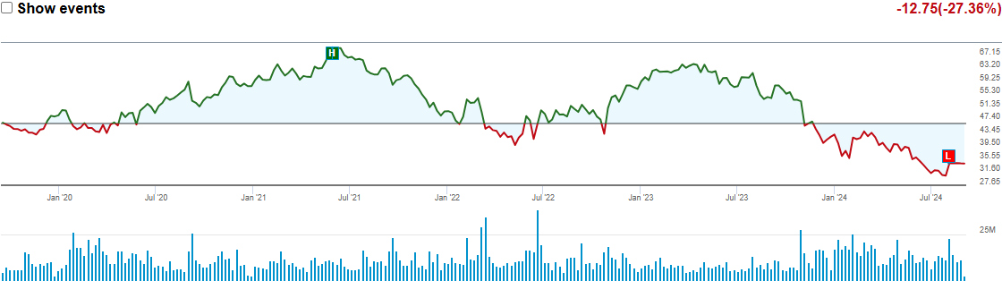

Opportunity: (Go to trading section at bottom for more)
Yum China, particularly through its KFC brand, has become a dominant player in China's fast-food industry by adapting to local tastes and consistently innovating its menu (On a far larger scale than in the US). Yum China's products are sourced almost all locally (which helps to keep costs manageable), positions KFC and Pizza Hut as more "authentic" Chinese brands (despite their obvious Western roots), and strengthens the company's relationships with national and regional government officials and that its supply chain is run at a unit cost 50% lower than industry average. KFC was the first Western fast-food chain to enter China in 1987, and it transformed from a novelty to a beloved brand by offering a wide variety of flavors and a welcoming atmosphere. Today, KFC holds a significant market share in China, far surpassing competitors like McDonald’s in both quick-service chicken and pizza categories.
This success is largely due to Yum China's strategic innovations, including a robust menu that changes frequently, and the use of technology to enhance customer loyalty and experience. With 380 million members on its rewards app and 90% of sales being digital, the company leverages AI to personalize menus and streamline ordering, driving higher sales and improving customer satisfaction. These opportunities are crucial because they demonstrate how Yum China has secured a competitive edge in a rapidly growing market, ensuring long-term success and profitability.

Balance Sheet:
The company's balance sheet is sound with no debt. Over the next years, we think the company will use some of its excess cash to acquire other restaurant concepts and drive shareholder returns through expansion.
The group's current cash flow can comfortably support its quarterly dividend at USD 0.16 per share and can afford to even raise its distributions. Prior to the outbreak of covid-19, the dividend payout ratio was around 25%, and we expect the number to go up over the next couple of years gradually. Yum China resumed its share buybacks in 2021.
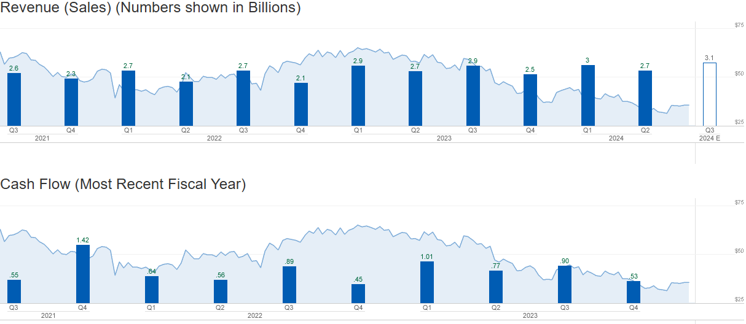
Management:
1. Joey Wat - Chief Executive Officer
- Background: Joey Wat became CEO of Yum China in March 2018. She joined the company in 2014 as President of KFC China and later served as COO before her promotion to CEO. Before Yum China, she was the Managing Director of Watsons UK, a subsidiary of the A.S. Watson Group.
2. Andy Yeung - Chief Financial Officer
- Background: Andy Yeung has been the CFO of Yum China since October 2019. Before joining Yum China, he served as CFO at Smart Global Holdings and NXP Semiconductors. He also held various finance leadership roles at Honeywell and Motorola.
3. Johnson Huang - President of KFC
- Background: Johnson Huang has been with Yum China since 2006, holding various leadership roles within the company, including Senior Vice President and General Manager of KFC. He was appointed President of KFC in 2018.
4. Alice Wang - Chief People Officer
- Background: Alice Wang joined Yum China in 2019 as Chief People Officer. Before that, she held senior HR roles at PepsiCo and other multinational corporations.
5. Danny Tan - Chief Supply Chain Officer
- Background: Danny Tan was appointed Chief Supply Chain Officer in 2020. Before this, he had a long tenure at Yum! Brands, where he held various leadership positions in supply chain management and logistics.
There are a few other management members that have entrepreneurial experience. In other words, the board members and top executives of YUMC have a strong mix of experience across the restaurant, finance, marketing, and international markets industry. The leadership team is well-equipped to steer the company through growth and expansion phases, the question is however, can they keep costs low/competitive, while simultaneously adding thousands of restaurants to their portfolio.

Metrics:
For a company like this (And most companies) important metrics include margins, revenues, debt, earnings, and sales. Some metrics like operating margin or D/E need to be improving over time to show management is keeping costs low and a firm hand on their financing for expansion. However, millions of dollars are needed for sales and advertising to help grow and compete with companies such as McDonalds. So we are looking for improvement over time and projected improvements to make sure the company and dividend stay healthy.
Operating Margin – 10.32% (6.76% in 2014 with constant increase)
Gross profit Margin – 17.17% (12.13% in 2014 with constant increase)
Total Debt – 2.71B on 13B market cap is nothing to worry about (Some debt is a good thing)
Dividend Coverage Ratio – 368% (They can pay out 3x more in dividends from Net income then they currently are)

Trading: (This is the good part)
Buys across the board from the CEO, CTO, Directors, Senators, CPO and all in past few weeks at the price it is trading at now.
Projected:
Morningstar Fair Value - $76.00 with 1 star of $102.60
Refinitiv - $45.53
MarketBeat - $51.20

Risks:
Primary risks include their ability to keep costs lower than competitors, geopolitical risks with US and China relations, family size and average amount of disposable income, ability to expand into untouched markets in smaller/poorer cities across the country.

