SONIFY SYN

Business

Sanofi develops and markets a wide range of drugs, focusing on oncology, immunology, cardiovascular disease, diabetes, over-the-counter treatments, and vaccines. Despite this broad portfolio, the company decided in late 2019 to withdraw from the cardio-metabolic area, which will likely reduce its presence in this significant therapeutic field. Sanofi's product lineup is diverse, with its top revenue generator, Dupixent, accounting for just over 20% of total sales, though profits from Dupixent are shared with Regeneron. Approximately 40% of Sanofi's revenue comes from the United States, 25% from Europe, and the majority of the remainder from emerging markets. The company provides specialty care in areas such as neurology and immunology, rare diseases, oncology, and rare blood disorders, alongside treatments for diabetes and cardiovascular diseases and established prescription products. Additionally, Sanofi collaborates with numerous small firms in the discovery and development of new drugs.

Opportunity

* Sanofi is planning the development of a covid-flu vaccination combination with a licensing agreement with Novavax, but early-stage data is not likely until early 2025. Based on how the technologies work independently, the combination should work, but early-stage data is still being processed.
* Sanofi will begin selling the Novavax covid vaccine in 2025 and potentially a covid-flu combination vaccine (in late-stage development) that Novavax is developing.
* Sanofi's wide lineup of branded drugs and vaccines and robust pipeline create strong cash flows and a wide economic moat. Growth of existing products and new product launches should help offset upcoming patent losses.
* Sanofi's patent-protected drugs have strong pricing power, allowing the company to earn high returns on its investments. Patents also give Sanofi time to develop new drugs before facing generic competition. The company's established products generate significant cash flow, funding the nearly $1 billion development cost per new drug. Additionally, Sanofi's robust distribution network makes it an attractive partner for smaller drug companies. Sanofi's strong presence in rare diseases, consumer health, and vaccines provides competitive advantages through efficient scale, brand power, and cost benefits.

Metrics

Revenue – Inconsistent revenues, ranging from -.44% to 15.86% growth in the last 10 years. With 34.11 billion in 2014 and 46.70 projected in 2024.

ROA – AVG at about 4.5% for last 10 years which beats competitors

ROE – AVG about 8% for last 10 years which also beats most competitors

ROI – AVG about 7% for last 10 years which beats most competitors

5-year sales growth – 5% which is not bad and in line with competitors

The operating margin hovers around 20% which beats all competitors, but the OM is not improving and is kind of sporadic year to year.

Gross Profit – 68% consistent growth since 2014

18 billion in debt for a 120 billion market cap company is very manageable. Especially with a little more than 10 billion in cash from operating activities in the last 3 years.

Management

Sanofi (ticker SNY) is led by CEO Paul Hudson, who has been with the company since September 2019. Before joining Sanofi, Hudson was the CEO of Novartis Pharmaceuticals and held senior positions at AstraZeneca and GlaxoSmithKline. His extensive experience in the pharmaceutical industry includes roles in the US, Japan, and Europe. Hudson holds a degree in economics from Manchester Metropolitan University and an honorary Doctor of Business Administration from the same institution

The Chairman of the Board of Directors is Frédéric Oudéa, whose term expires in 2027. The board includes several independent directors with varied backgrounds, such as Clotilde Delbos, Anne-Françoise Nesmes, and Rachel Duan, who bring experience from companies like Renault, Smith + Nephew, and Alstom​

Dividends

As you can see, they pay a yearly dividend of $2.04, and that number has been up and down throughout the years. They haven’t maintained stable dividend growth over the last 10 years which is something to look at. During COVID they raised their dividend 13% from 2020 to 21 and 6% from 2021 to 22. These were their biggest increases in the last 10 years but with their great cash flow you can expect some stability going forward.

Trading

333 million shares bought by institutional investors in 2024 Q1 and only 24M sold

10.04% current institutional ownership

389 institutional buyers and 281 sellers in last 12 months

Final Thoughts

When it comes to Pharmaceuticals, there are a few key things to keep in mind for the company's future. The first being patents and when they are expiring. Companies that spend billions on R&D to come up with new drugs must make up their profits inside the 20-year timetable that the patent provides before all the generic brands come out with their own product. The second thing to look for is a return on investments. Since these pharma companies spend so much on research and development, it is important to look at how far along they are in the process of getting a drug approved and how much longer until it come to market. Then making sure they are receiving great returns on all of their investments, so metrics such as ROA, ROE, and ROIC are very important. For SYN they have good cash flows, a multitude of drug offerings, and enough partnerships to last them another decade. They are spending billions on R&D (Like most big pharma companies) and if it pays off then they could see some serious profits in the coming years. This stock has been hammered in the last few years and keeping in mind other websites’ price targets I like this company at this price.

[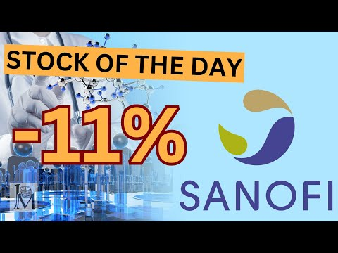](https://www.youtube.com/embed/szcYIcmg4gc?feature=oembed)