Comcast Corporation (CMCSA) Stock Analysis

## **Ticker**: CMCSA **Market Cap**: $152.11B **Current Price**: $40.00

### **Read Time**: **Analysis** – 6 Minutes, **5-year projection** – 5 minutes

**Business Description:**

Comcast is a global telecommunications conglomerate, offering services primarily through its cable and broadband divisions. While most people know Comcast for Xfinity, its residential internet and cable service, the company has a much larger footprint. Comcast also owns NBCUniversal, which operates a vast array of television networks, film studios, and streaming services like Peacock. Additionally, its Sky division gives Comcast a dominant presence in Europe.

This diversified portfolio makes Comcast a big player in the media and telecom industry, but it also means the company has its hands in numerous competitive markets.

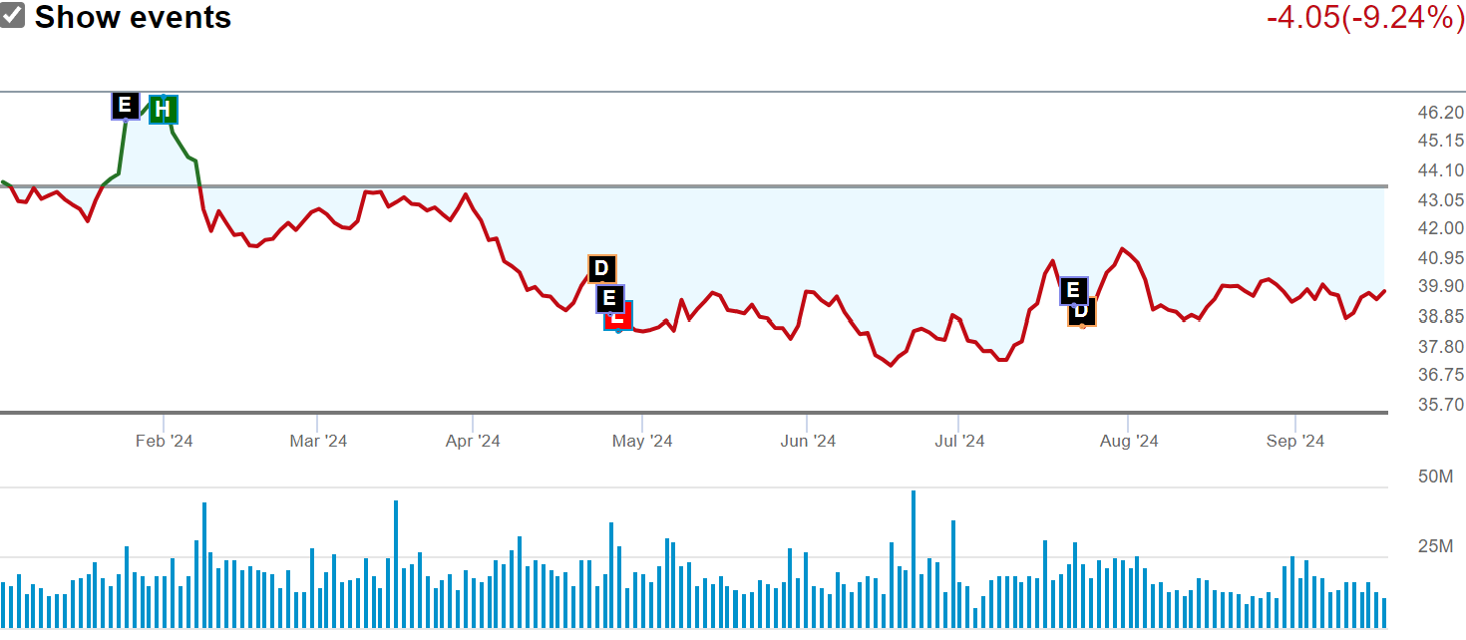

Figure 1 - Stock performance

**Opportunity:**

Comcast’s future largely depends on two key drivers: broadband growth and media content. While cord-cutting continues to impact the traditional cable business, broadband subscriptions have surged, offering Comcast a solid revenue stream. With high-speed internet becoming a basic necessity, Comcast is in a prime position to capitalize on this demand.

The biggest question is how effectively Comcast can evolve its media business. As streaming competitors like Netflix and Disney+ gain ground, Comcast's Peacock service is still in its early stages. Investors must ask: Can Comcast play catch-up in the streaming wars, or will it remain a secondary player?

On the positive side, Comcast is expanding its high-speed internet infrastructure, with an eye on 5G technologies and enhanced broadband services. These moves could be a growth catalyst in the future.

**Management:**

1. **Brian L. Roberts** – Chairman & CEO  
   Roberts has been with Comcast for decades and helped build the company into the behemoth it is today. Under his leadership, Comcast made strategic acquisitions like NBCUniversal and Sky, turning it into a major player in both telecom and media.
2. **David N. Watson** – President & CEO of Comcast Cable  
   Watson leads the cable division, which includes Xfinity. His focus is on improving customer satisfaction and expanding the broadband subscriber base.
3. **Jeff Shell** – CEO of NBCUniversal  
   Shell has the challenging task of steering Comcast's media division through the turbulent waters of streaming, network TV, and film production.

**Metrics:**

* **Revenue Growth**: Comcast has seen consistent revenue growth, but it has slowed in recent years as the cable TV business declines. However, broadband revenue continues to rise, offsetting some of the losses from cord cutting.
* **Debt**: With $94 billion in debt, Comcast has a hefty balance sheet to manage. However, its cash flow generation is strong, which allows it to service this debt without too much concern for now.
* **Free Cash Flow (FCF)**: Comcast is a cash flow machine, generating billions in free cash flow annually, which it uses for dividends, share buybacks, and infrastructure investments.
* **Dividend Yield**: 2.6%. Comcast has a healthy dividend, which makes it attractive for income-focused investors.

Figure 2 - Dividends

**Trading Metrics:**

* **Percentage Held by Institutions**: Around 85% of Comcast shares are held by institutions, signaling strong market confidence in the company’s stability.
* **Price Targets**:
  + **MarketBeat**: $52.00 (~17% upside)
  + **Morningstar Fair Value**: $50.00 (~13% upside)
  + **Refinitiv**: $51.50 (~16% upside)

**Final Thoughts:**

Comcast’s key strength lies in its broadband dominance, which is unlikely to face serious challenges anytime soon. While its cable division may be declining, the company has been smart about pivoting towards broadband and media. The big question mark is Peacock—can it ever really compete with Netflix, Disney+, or Amazon Prime?

Comcast’s future looks stable, but it may lack the explosive growth potential of younger, more nimble competitors. If you're a conservative investor looking for steady income and a foothold in telecom and media, Comcast might be worth holding onto. Just be ready for some ups and downs as the company navigates the rapidly changing media landscape.

5-Year Projection **(Short version with in-depth review below)**

* **Broadband**: Steady growth, driven by increasing internet demand and infrastructure improvements.
* **Media**: Challenges as Peacock competes in the streaming landscape. NBCUniversal will have to adapt to changing viewing habits.
* **Cable TV**: Continued decline but offset by broadband and mobile services.
* **5G & Technology**: Potential growth area, especially if Comcast leverages 5G technology effectively.
* **Financial Health**: Expect a focus on debt reduction, continued dividends, and possibly more share buybacks.

Figure 3 - Expected Earnings

Comcast’s 5-year outlook is a mix of both potential and challenges as it continues to navigate evolving industries like broadband, media, and telecommunications. Here’s a breakdown of some key trends and expectations for the next five years:

**1. Broadband Growth – *Comcast’s Core Strength***

Comcast’s broadband division is expected to remain a key growth driver over the next five years. With the increasing reliance on high-speed internet for remote work, streaming, gaming, and smart home technology, Comcast is well-positioned to capture ongoing demand. The company has been expanding its fiber network and upgrading its broadband services, which should provide a steady revenue stream. The potential for expansion into 5G and mobile broadband may further bolster its connectivity segment.

**Outlook**: Expect consistent growth in broadband subscriptions and revenue, especially as Comcast invests in infrastructure upgrades.

**2. Streaming Wars and Media Transformation**

One of the biggest challenges Comcast will face is keeping its media arm relevant in a world dominated by streaming services. NBCUniversal’s streaming service, **Peacock**, has gained some traction but still lags behind major competitors like Netflix, Disney+, and Amazon Prime. The next five years will be critical in determining whether Peacock can grow its subscriber base and become a meaningful player in the streaming space or if it will struggle to compete.

Comcast’s ownership of content and its production capabilities through NBCUniversal and Universal Studios are valuable assets, but it will need to innovate to retain viewership in an increasingly fragmented media environment. International expansion through Sky could provide growth, but competition remains fierce.

**Outlook**: Media will be a battleground, with streaming continuing to be a focal point of investment. Success in this area is uncertain, but the company has the resources to make a real push.

**3. Declining Cable TV**

Traditional cable TV is in decline as consumers continue to cut the cord in favor of streaming platforms. Over the next five years, Comcast’s legacy cable television business is likely to experience ongoing subscriber losses. The company is countering this by bundling broadband and streaming services, but it’s clear that the future of TV is online, and Comcast will need to minimize the damage caused by cable's shrinking relevance.

**Outlook**: Expect further revenue loss from the cable segment, but it will be offset by growth in broadband and other areas.

**4. 5G and Technological Innovation**

Comcast has already ventured into mobile services through **Xfinity Mobile**, but the rollout of 5G technology presents both opportunities and risks. The company has been exploring partnerships and investments in 5G infrastructure, which could enhance its mobile offerings and help it compete with telecom giants like Verizon and AT&T.

**Outlook**: A potential growth driver if Comcast invests wisely in 5G and integrates it into its existing offerings. This could also strengthen its position in mobile and broadband convergence.

**5. Debt and Capital Allocation**

Comcast’s $94 billion in debt is substantial, but the company has a strong cash flow to manage it. Over the next five years, debt reduction will likely be a focus, especially if the company wants to maintain or increase its dividend payouts and buyback programs. Investors can expect Comcast to balance between paying down debt, investing in growth (especially in broadband and streaming), and returning capital to shareholders.

**Outlook**: Stable financials, with likely emphasis on debt management, continued dividends, and possible share buybacks.

**6. Sky and International Expansion**

Comcast’s acquisition of **Sky**, a major European TV and broadband provider, offers a gateway to international growth. Over the next five years, Sky will likely be leveraged for further expansion into Europe. However, economic conditions and local competition could present challenges. Sky also provides content and distribution that Comcast can integrate with its other businesses, especially Peacock.

**Outlook**: International growth through Sky will be a priority, but success depends on both execution and the overall health of European markets.

**Conclusion:**

Comcast’s future seems relatively stable, with broadband acting as its growth engine. However, the company's performance in media and streaming, as well as its foray into 5G, will be key factors in determining its overall success. For investors, Comcast is likely to offer solid returns, particularly for those looking for a combination of income (through dividends) and some moderate growth potential.