# CELH Celsius Holdings Inc

Ticker – CELH

Market Cap – 9 Billion

Current Price - $38.15

**Business Description:**

Celsius Holdings, Inc. creates and sells energy drinks and liquid supplements both in the U.S. and worldwide, including places like Australia, Canada, Europe, and the Asia-Pacific region. Their main product, CELSIUS, is a fitness drink meant to boost metabolism and help burn fat. They offer a variety of flavors, including both carbonated and non-carbonated options, under the CELSIUS Originals and Vibe brands. They also have CELSIUS Essentials, CELSIUS On-the-Go Powder, and ready-to-drink versions. You can find their products in supermarkets, convenience stores, health clubs, gyms, and online, as well as through distributors and direct delivery to stores.

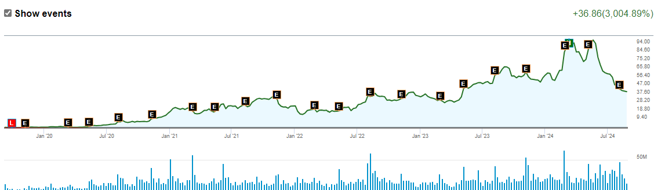

**Opportunity:**

This is very much a growth company and the opportunity (If you believe there is one) totally relies on your belief that this company will continue to expand, and people will still use their products. I know people that drink 3 celsius’s a day and also people that think it is disgusting. The opportunity lies in the fact that they have just recently in the past few years become profitable and have positive cash flows. Their cash flow statement took on a lot of green in the past 2ish years and sales growth is expected to stay in the 20% range.

Now they are not the best drink for no/low sugar and the beverage market is very competitive. So, do you believe this drink will be able to grow worldwide? Will European countries adopt it more and more? The opportunity is the chance for extreme growth in the next few years with more international sales as most of their revenue comes from the US and Canada right now. So, let’s dive in a little more to see if this growth can be expected or if the slowed growth is foreshadowing for the future.

**Management:**

1. John Fieldly - CEO & President

Experience: John Fieldly has been with Celsius Holdings since 2012 and became the CEO in 2018. Before joining Celsius, he had significant experience in finance and operations, including leadership roles at various companies. His financial intelligence and deep understanding of the brand have been instrumental in the company’s growth.

2. Hal Kravitz - Chairman of the Board

Experience: Hal Kravitz is a beverage industry veteran with over 30 years of experience. He has held key leadership roles at **Coca-Cola, including Chief Revenue Officer**. His expertise in brand strategy and market expansion is highly valued at Celsius.

3. Nancy J. Quan - Director

Experience: Nancy Quan has extensive experience in the food and beverage industry, having served in leadership positions at Coca-Cola and Mars, Inc. She is recognized for her innovation and supply chain expertise.

4. Kevin Harrington - Director

Experience: Kevin Harrington is an entrepreneur and a pioneer of the "As Seen on TV" industry. He is one of the original "Sharks" on the TV show Shark Tank and has helped launch over 500 products, generating billions in sales.

There are a few other directors that include lawyers and entrepreneurs. In other words, the board members and top executives of Celsius Holdings, Inc. have a robust mix of experience across the beverage industry, finance, branding, and international markets. The leadership team is well-equipped to steer the company through growth and expansion phases, there is just the question of how they can break through with a competitive advantage.

**Metrics:**

For a growth company like this important metrics include sales, revenues, debt, earnings. Some metrics like ROIC or ROI can look horrible because of the amount spent and not necessarily received back. However, this is a growth company, and millions of dollars are needed for sales, advertising, shipping, and research to help grow. So just because the metrics are in the trash this shouldn’t be a huge turn-off as long as the company is showing improvements and has a plan.

**Revenue Growth** – From 14.61 million in 2014 to 1,489 million in 2024 with average growth year over year at around 60%.

**Operating income** has also improved from -1.53 million and negative growth in 2014 to 334 million and 20% growth in 2024.

**Debt –** 1.78 million for a company with a $9B market cap is not bad at all.

**Trading -** Percentage Held by Institutions - 60.95% of the stock of Celsius is held by institutions. High institutional ownership can be a signal of strong market trust in this company.

9.17% of Shares Sold Short which is more bearish.

**Price Targets** –

MarketBeat - $64.79 (68.7% upside)

Morningstar Fair Value - $36.00 with a 1-star price of $63.00

Refinitiv - $62.69 (66% upside)

**Final Thoughts**

For a company like this you need to look at revenue, sales, and earnings growth and if this company is continuing to grow without issuing too many shares or taking on too much debt. In this case Celsius is doing a good job of growing and they still have most of their products in the US, which means they have a whole market outside of the US to grow into. Some concerns include the competitive nature of the beverage company, as a few companies dominate the subsector, and it is difficult to break into. Celsius has done a good job so far of diversifying themselves and growing and I believe they could continue to do this in the future.