Company - Expedia
Ticker - EXPE


Business Description:
Expedia Group, Inc. operates as an online travel company in the United States and internationally. It operates through B2C, B2B, and trivago segments. B2C segment includes Brand Expedia, a full-service online travel brand offers various travel products and services; Hotels.com for lodging accommodations; Vrbo, an online marketplace for the alternative accommodations; Orbitz, Travelocity, Wotif Group, ebookers, CheapTickets, Hotwire.com and CarRentals.com. The company’s B2B segment provides various travel and non-travel companies including airlines, offline travel agents, online retailers, corporate travel management, and financial institutions who market Expedia Group rates and availabilities to its travelers. Its trivago segment, a hotel metasearch website, which send referrals to online travel companies and travel service providers from hotel metasearch websites.
First, I know what you are thinking, the cost of living is insane right now, interest rates are through the roof and do not look to come down till December, so why is investing into a travel website a good idea? And that is exactly the reason why you should invest. "The IATA predicts that the number of passengers traveling by air will reach 4.7 billion in 2024, a jump from the 4.5 billion passengers who traveled in 2019," A quote taken from Forbes. Everyone is thinking the same thing so that means I believe the stock is priced at what believe will happen with travel.

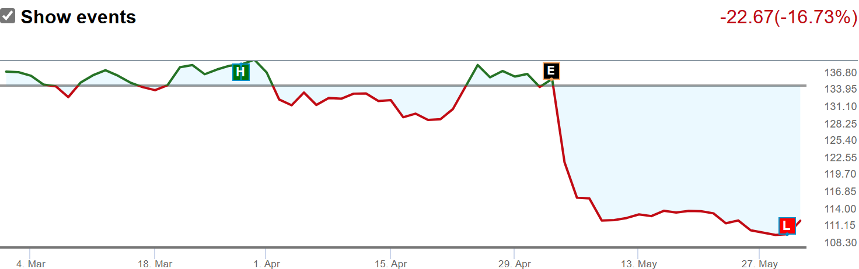
However, as we read and you can read more into if you would like, travel is not expected to slow down, it is predicted to increase. Multiple sites made surveys where interviewed people said they were expecting to travel more than they did pre covid such as the TSA Government Website.
The extreme drop off came from a projected missed earnings call and as Warren Buffet says, "Bad news is an investors best friend," cause you can get good stocks for cheap.

Metrics
Operating revenue and Gross profit have both returned and exceeded pre covid levels, with OR being 12,067 million in 2019 and 12,839 in 2023 and GP going from 10,001 to 11,266 in the same time frame.
Return on Equity - 59.29 which is significantly higher than competitors
1 year sales growth is about 8% which is in line with competitors and not bad at all.
They have great margins with a high profit margin of 88 which beats all competitors and operating, and net profit margin are in line with their competitors.
Current ratio is less than 1 so they have more debt than assets which is something to look at

Trading
In the last 100 trades there were 548.53 thousand shares bought and 378.39 thousand shares sold. The large number of stock bought compared to stock sold indicates that the insiders believe there is a potential good upside. In some cases, larger purchases can be explained by due date for stock options.
Refinitiv maintains a stock price target of about $146 from the current $112.

Final Thoughts
If Expedia continues to fall or falls to double digits, I think this could be a great stock to add to a portfolio. I believe limited travel is priced into the stock, when in reality travel is expected to continue growing and reach all-time highs. Their sales, revenue, and profit have returned and surpassed what they were before COVID, and they have good projections. A lot of analysts have either a Hold or slight Buy rating on this stock so this could be a good opportunity especially if it drops to the 90s. If anything, it is a good stock to look into that you might not have been aware off.

